**Estimating abundance of aggregated populations with drones while accounting for multiple sources of errors: a case study on the mass nesting of Giant South American River Turtles**

**Abstract**

1. Counting animals when populations are spatially aggregated (e.g., breeding or nesting colonies, stopover or haul-out sites) enhances the accuracy and efficiency of survey efforts for abundance estimation. Orthomosaics generated from drone images are commonly used to count aggregated populations, but these counts are subject to detection errors that are often overlooked in abundance estimation.
2. Motivated by the need for a monitoring protocol for mass nesting events of Giant South American River Turtles (*Podocnemis expansa*), we develop a novel modeling approach to estimate the abundance of spatially aggregated wildlife populations using drone-based counts in orthomosaics while accounting for multiple sources of error. We use a combination of mark-resight data and overall population counts to account for: i) open population during the nesting event; ii) individuals unavailable for detection during flight; iii) double counts due to the orthomosaic building process; and iv) marked individuals detected in the mosaic with unidentifiable marks.
3. From the mark-resight data, we estimated that the daily nesting probability is 0.37, and that 35% of the individuals that used the sandbank during the night are present during the morning drone flight. We also found that 20% of the turtles walking in the orthomosaic are double counts, and that the probability of identifying the mark in the carapace is 0.78. The total population size was estimated as ~41,000 turtles for the 12 days of nesting season, marking the current world’s largest known aggregation of freshwater turtles. By comparing our approach with an abundance estimate based on a simpler model and with visual ground counts, we demonstrate the benefit of our approach and the importance of accounting for the multiple sources of error when counting animals in orthomosaics.
4. *Synthesis and applications*: The developed approach can be applied to several contexts to efficiently survey spatially aggregated populations using drone-derived orthomosaics, and to understand phenology at these aggregation sites. We provide general recommendations for planning surveys and discuss implementations of our approach using other types of marking methods and model assumptions.

**Authors may include up to eight keywords. These should highlight the key areas of your paper to maximise its impact. Keywords help with online searches and are crucial in driving readership and increasing exposure to your work. Keywords can be repeated from the title.**

**Please check you have uploaded a graphical abstract as a separate image file – refer to my email for more details.**

**At this stage, we also encourage authors to also provide a second abstract (in addition to the English abstract) in their own / a second language, or a language relevant to the country in which the research was conducted. This can also help your published article show up in more search engines. Please feel free to provide multiple languages if this is relevant. Non-English abstracts are published with the HTML version of the article and are not included in the PDF. Please note that second abstracts are not copyedited and are published as provided by the authors. If you wish to take advantage of this option, please provide a translated abstract here, below the English language version.**

**1. Introduction**

Abundance is a fundamental variable in ecology and conservation, for instance, to study the dynamics of populations, predator-prey and interspecific interactions, as well as to assess the impacts of habitat conversion and global climate change. Moreover, by monitoring abundance through time, it is possible to detect and predict trends in populations of game, invasive, or threatened species, together with assessing the effectiveness of management actions to control or increase these populations (Butchart et al., 2010; Moussy et al., 2022). However, estimating abundance can pose significant challenges, particularly in vast and extensive areas where species occur at low densities, making it difficult to detect individuals and to obtain accurate counts. Conveniently, several wildlife species exhibit seasonal behaviors in which individuals concentrate in small areas to rest, interact socially, mate, breed, and/or nest, providing a great opportunity for counting them (Brown, 2016). For example, waterbirds gather in nesting colonies (Jovani et al., 2016; Rolland et al., 1998), seals aggregate at haul-out and breeding sites (Hoekendijk et al., 2023; Procksch et al., 2020), birds jointly use stopover sites during long-distance migrations (Cohen et al., 2021; Schmaljohann et al., 2022), and turtles synchronously nest in sandbanks and beaches (Forero-Medina et al., 2021; Scheelings, 2023). Therefore, counting animals during these periods of spatial aggregation can significantly enhance the accuracy and efficiency of survey efforts for estimating and monitoring abundance.

Recently, drone-based surveys have emerged as an efficient and less-invasive method for sampling spatially aggregated wildlife populations (Christie et al., 2016; Linchant et al., 2015; Lyons et al., 2019). Using drones (also known as unoccupied aerial vehicles, UAV; or remotely piloted aircrafts, RPA) to count aggregated individuals from above has been shown to be more accurate and precise in comparison with ground-based surveys (Goebel et al., 2015; Hodgson et al., 2016, 2018; Ratcliffe et al., 2015), while also causing less disturbance to the animals (Krause et al., 2021). A common protocol used for drone surveys is to plan flights with a high overlap between successive photos and lateral strips, merging the collected images into a single orthorectified mosaic (i.e., orthomosaic; Westoby et al., 2012; Wolf et al., 2014). When sampling aggregated populations, these flights usually cover the entire area where individuals are gathered (e.g., a bird colony area, Weinstein et al., 2022; or a seal haul-out islet, Procksch et al., 2020).

However, counting wildlife individuals in orthomosaics during these aggregation events is subject to some unintended sources of errors, potentially biasing abundance estimates if not properly addressed (Brack et al., 2018). For instance, an individual may not be observable in the collected imagery (i.e., unavailable for detection) by being hidden below vegetation, under water, or temporarily outside the flown area (e.g., foraging elsewhere). Additionally, even if the individual is observable in the images, a human observer or a detection algorithm can fail to detect it. Furthermore, animals that move during the drone flight can appear multiple times at different locations in the photos used to create the orthomosaic (Figure 1). Finally, an important characteristic is that these aggregations are commonly temporary, with individuals arriving and leaving over the course of days, causing fluctuations in the population size. For example, during the nesting, breeding, or migratory seasons of birds and seals, individuals can arrive and depart from the colony area in different days throughout the season. This “open population” characteristic might lead to biased estimates of abundance if not accounted for. Worryingly, these errors are widely overlooked in abundance estimations derived from orthomosaic counts of drone-based surveys.

**Figure 1.** Example of double count of a marked river turtle in the resulting orthomosaic from drone surveys.

In this study, we aim to develop a novel approach to estimate abundance of spatially aggregated wildlife populations using drone-based counts in orthomosaics while accounting for multiple sources of error. The approach relies on the combination of two types of datasets: resights of marked individuals and overall population counts. This study was motivated by the need to estimate the abundance and elaborate a monitoring protocol for Giant South American River Turtles (*Podocnemis expansa*, referred onwards simply as “river turtles”) during the world’s largest known aggregation of freshwater turtles. Every year during the dry season, thousands of river turtles gather to nest in sandbanks and beaches of the Guaporé/Iténez River, along the Brazil-Bolivia border (Amazon basin) (Figure 2). While these mass nesting events used to be common across the Amazon and Orinoco basin, populations have considerably declined mainly due to overexploitation for meat and eggs consumption, and these large aggregations are now rare (Forero-Medina et al., 2021). Previous methods for estimating river turtles’ abundance relied on counting hatchlings once they emerge (and then extrapolating the number of females using the average number of eggs per nest), or visual counts of adult turtles from the ground (Alvarez, 2006). Counting hatchlings is an invasive and time-consuming method since it requires fencing the sandbank perimeter and manipulating a great number of hatchlings. Visual ground counts of adult turtles also present limitations due to the difficulties imposed by counting thousands of individuals that obstruct each other and are in constant movement. Recently, drones have been tested to survey river turtle populations (Fagundes & Ferrara, 2022), holding great promise as a standardized, precise, and efficient method for estimating population sizes during these nesting events. This is key for assessing population trends and the effectiveness of conservation actions for the species.

We apply the developed modelling approach to estimate the population of river turtles during a mass nesting event. We account for multiple sources of errors, such as individuals’ availability, individuals joining and leaving the local population during the sampling period, and double counts due to the orthomosaic building process. Although initially inspired to improve the monitoring of river turtles, the developed framework is very versatile and can be readily used or adapted to several different contexts in which aggregated populations are surveyed using a drone orthomosaic. We therefore discuss the applications and expansions of the developed method for other wildlife surveying scenarios.

**2. Materials and Methods**

***2.1 Study area***

**Field studies must have appropriate licences and permits to carry out the work, and details of these should be given in the methods section of the manuscript, including details of the body that granted them and relevant licence and permit numbers. If you did not need permission for fieldwork, please state this regardless. If your study did not involve fieldwork please disregard this.**

**Please let us know whether or not you received ethical approval for this research from an appropriate animal ethics committee. If you received ethical approval please add a statement to this effect to your methods section, stating the body that granted approval and any relevant approval numbers. If your study did not require ethical approval please state this in your methods section regardless. If your study did not involve animals in any way then please disregard this.**

Please address this only if your research involved human participants:

Please clarify whether or not you received written informed consent from participants to participate in this research, and provide a statement in your manuscript briefly outlining the consent procedure. If verbal, rather than written consent was received, please briefly explain why.

If you used one, please upload a copy of your questionnaire or interview questions as Supporting Information.

The study was conducted in the Guaporé/Iténez River, one of the major tributaries of the Madeira River, in the Amazon basin (Figure 2). The Guaporé/Iténez stretches approximately 1,210 km, most of which runs along the Brazil-Bolivia border. Annual precipitation in the area ranges between 1,500-1,600 mm, distributed in two distinct seasons, a rainy (December – May) and a dry (June – November) period (Pouilly et al., 2012). During the low water level season, large sandbanks and beaches emerge, which are used by river turtles to nest.

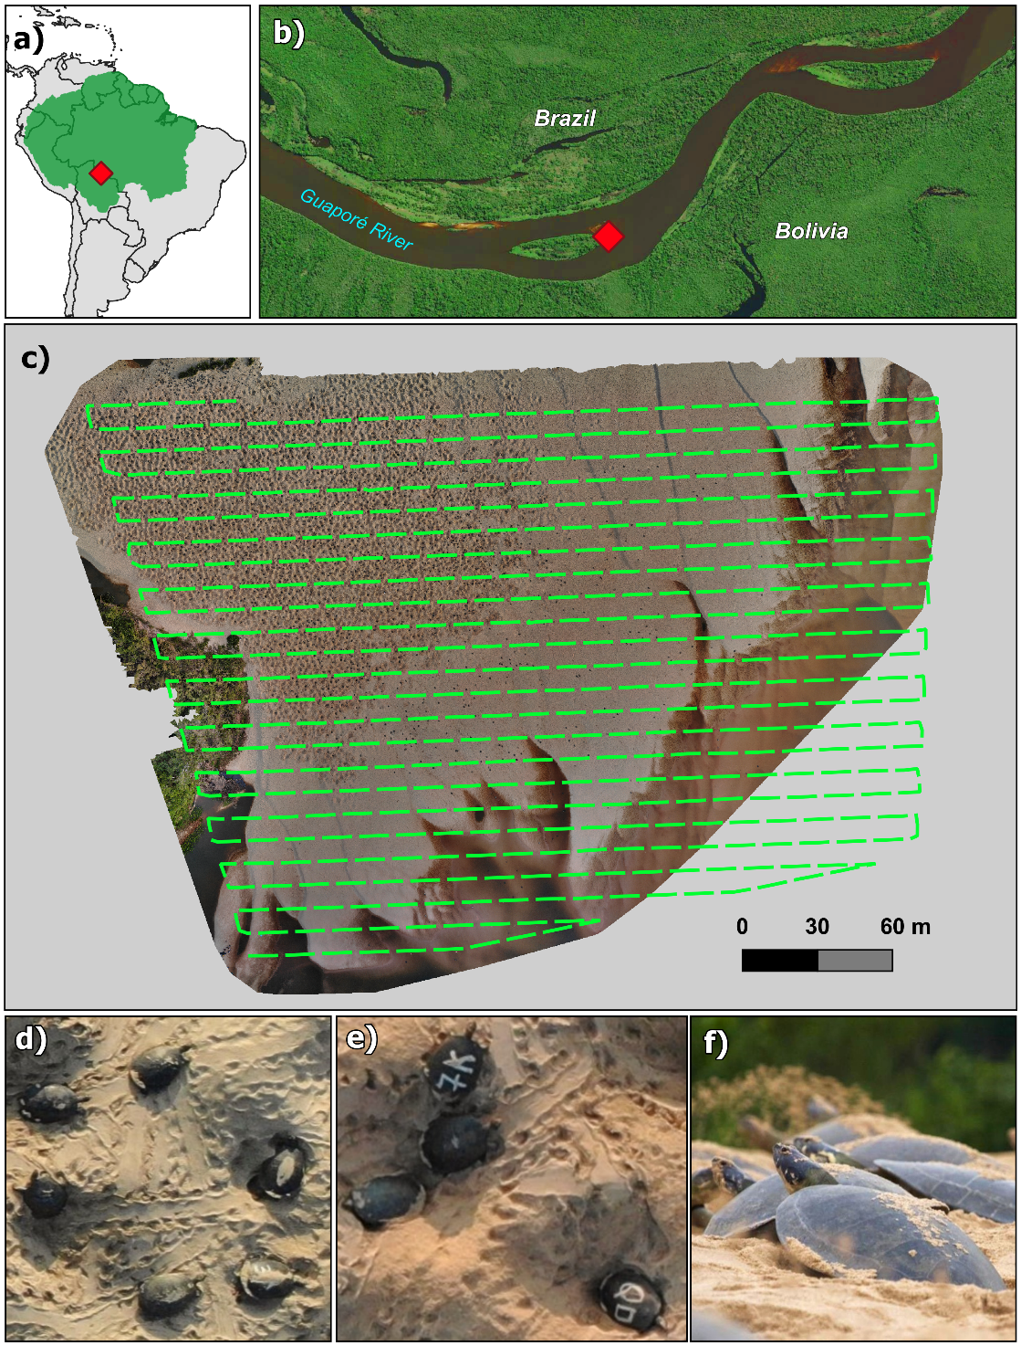

**Figure 2.** a) Location of the study area (red diamond) in the Amazon (green shadow). b) Sandbank in the Guaporé/Iténez River (Brazil-Bolivia border) where Giant South American River Turtles (*Podocnemis expansa*) were surveyed. c) Planned drone flight path and resulting orthomosaic of the sandbank area during the turtle mass nesting event. d-e) Top-view of the turtles aggregating to nest in the sandbank. Some individuals were marked to allow the estimation of detection errors in counts. f) Ground-level view of the turtles nesting.

The Giant South American River Turtle is one of the most social of freshwater turtles (Ferrara et al., 2014), traveling the rivers in large groups, and gathering in front of the nesting sandbanks around July or August in this part of the Amazon. The female river turtles nest synchronously in particular sandbanks that they select for this purpose (Alho & Pádua, 1982; Ferrara et al., 2010), starting when the water levels are lowest (September through November). The mass nesting event at the Guaporé/Iténez is the largest known for the species across its whole range (Forero-Medina et al., 2021). While river turtles may use several sandbanks to nest each year, we selected a particular one in 2021 (*Praia da Ilha*) to survey the population (Figure 2). This sandbank was the main nesting site for that year, concentrating most of the individuals and presenting the largest mass nesting. River turtles leave the water and enter the sandbank usually during the night (Vogt, 2008). Some individuals nest that same night, while others explore the area to return on a different night to nest (Ferrara et al. 2023). An individual can enter the sandbank several times before nesting, and after nesting it does not return to the sandbank (Ferrara et al., 2023).

***2.2 Data collection***

Drone surveys were conducted daily between September 26 and October 04 of 2021, starting immediately after sunrise, around 6 am. We used a multirotor drone DJI Mavic 2 Enterprise Advanced carrying a 48 Mpx visible sensor. To cover the entire sandbank, we conducted four consecutive flight missions that took a total of approximately one hour per day to finish. We programmed the drone flights at 50 m above ground level, with 80% of frontal and 70% of lateral overlap. These flight settings resulted in a ground sampling distance (GSD) of 1 cm. The four flights of each day resulted in approximately 1,500 photos per day. Previous to each drone survey (around 3 am), we marked approximately 100 individuals that were on the sandbank, painting unique symbols over their carapaces with white paint, with the goal of identifying them later at the drone images (Figure 2e).

The photos collected in each day were stitched together into daily orthomosaics using the OpenDroneMap™ software (<https://www.opendronemap.org/>) (Figure 2c). Two observers reviewed each daily orthomosaic in the QGIS software, using a grid to guide the search, and annotating all river turtles detected. When the turtle had a marked carapace, it was identified when possible or annotated as an unidentified mark (usually because the individual had sand on its carapace). Additionally, each detection (for both unmarked and marked individuals) was classified into either nesting or walking (see section 2.3). Nesting individuals could be distinguished from the walking ones as they were in the core area of the sandbank, within a hole in the sand, and with their bodies tilted downward at the rear end. We did not include mark-resight data for September 30 (i.e., we only used the overall counts) because the poor quality of the resulting orthomosaic (the very cloudy weather resulted in dark photos) precluded the identification of marks.

We organized the mark-resight data into three subsets, one conventional multistate capture-recapture matrix and two types of daily counts of these marked individuals. The first subset was composed of the encounter history of each detected individual (encounter history matrix with individuals in rows and days in columns). We filled each row with 1, 2, or 3 if the individual was detected as walking, nesting, or not-detected, respectively. In the second subset, we tallied the total number of marked individuals that had their marks either identified or unidentified in each day. This subset was used to account for the bias resulting from marked individuals present in the orthomosaic but with marks not identified. In the third dataset, we compiled the number of detections corresponding to either unique individuals or repeated detections of the same individual (i.e., double counts) for each day, considering only the marked individuals classified as walking. Finally, aside from the mark-resight data, the overall counts dataset was composed of total number of walking and nesting individuals detected at each day in the orthomosaic.

***2.3 Model approach and fitting***

Using the mark-resight data and the overall counts, we developed a novel modelling approach to estimate the total abundance of aggregated populations while accounting for the following sources of variation:

1. Open population: individuals enter the sandbank for the first time on different days throughout the nesting event. These individuals can visit the sandbank multiple times before nesting but they do not return to the sandbank after nesting.
2. Individual states: an individual can be in either of two states in a given day: walking or nesting. Individuals walking are typically exploring the sandbank and can return in another day, while nesting individuals are usually sunken in the sand and do not return to the sandbank.
3. Unavailability: an individual that is part of the population can be outside the sandbank (i.e., in the water) during the drone flight and therefore will be unavailable for detection.
4. Double counts: some individuals that are walking during the drone flight can appear more than once in the orthomosaic.
5. Unidentified marks: it may not be possible to identify some individual marks because of sand obstructing them.

The proposed modeling approach has two components, one for the mark-resight data and one for the population count data (Figure 3). We provide a more detailed model description in the Appendix S1. The first component is a multistate open-population capture-recapture model for the mark-resight data (Calvert et al., 2009; Kendall et al., 2006; White et al., 2010), that was adapted to include the probability of identifying the mark of an individual and the proportion of double counts (mark-resight model in Fig. 3). Using a state-space formulation (Gimenez et al., 2007; Kery & Schaub, 2012), we modeled the biological state and the detection process of the individuals after the first capture (i.e., following the marking event) as categorical outcomes. The biological process is governed by the transition probabilities from the individual true state in time *t* to its state in time *t*+1 (Table 1a), while the detection process is defined by the probability of observing each state given its true state (Table 1b).

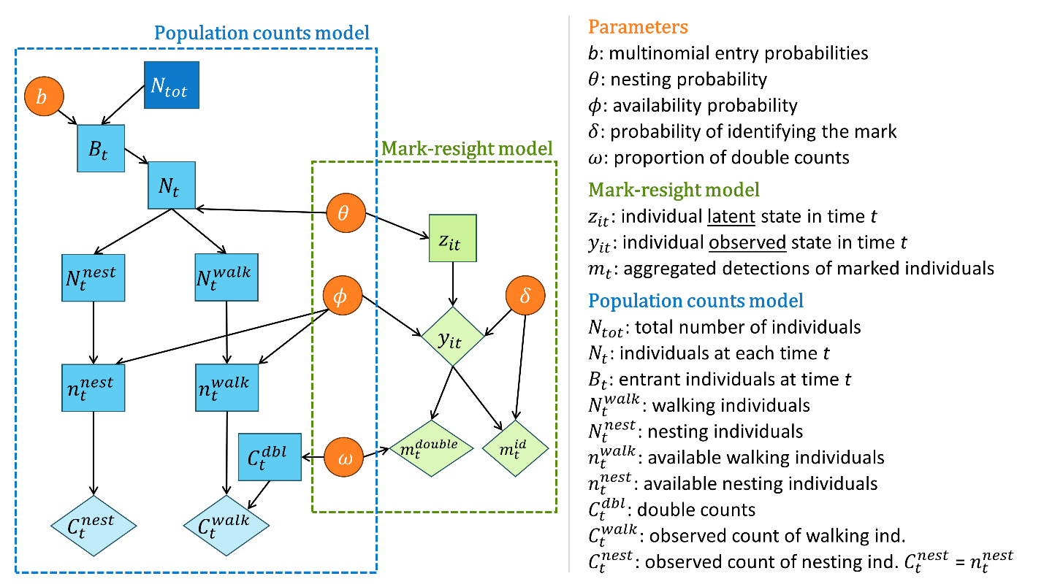

**Figure 3.** Directed acyclic graph for the combined modelling approach to estimate abundance from orthomosaic population counts and mark-resight data. Observed data, latent variables, and parameters are shown as diamonds, rectangles, and circles, respectively. Individual level mark-resight data are used to estimate parameters associated with the detection process and temporal dynamics of the overall population. The overall population counts are used to estimate the total abundance with a remaining parameter of the entry process.

We considered that each individual can be in one of three different latent states at each day: 1 = walking (i.e., not nesting); 2 = nesting; and 3 = gone (i.e., already nested and left the area). Thus, a new marked individual is defined as walking in the moment of marking, and it has a probability $θ$ to nest in the next drone flight. An individual can remain in the population (with a probability of $1-θ$) and return to the sandbank multiple times before nesting. If the individual nests, it leaves the area and does not return (Table 1a).

**Table 1.** State-transition and detection matrices used in the mark-resight model. a) Individual transition probabilities from true latent states between time *t* and *t*+1. $θ$ = nesting probability. b) Probabilities of observing an individual in a given state given its true state. $ϕ$ = availability probability. $δ$ = mark identification probability.

|  |  |  |  |  |  |
| --- | --- | --- | --- | --- | --- |
| **a) States transition matrix** | | | | | |
|  |  | *True state at time t + 1* | | | | |
|  |  | Walking | Nesting | | Gone | |
| *True state at time t* | Walking | $$(1-θ)$$ | $$θ$$ | | $$0$$ | |
| Nesting | 0 | 0 | | 1 | |
| Gone | 0 | 0 | | 1 | |
| **b) States detection matrix** | | | | | |
|  |  | *Observed state* | | | |
|  |  | Walking | Nesting | Not detected | |
| *True state* | Walking | $$ϕ_{j}δ$$ | 0 | $$\left(1-ϕ_{j}\right)+ϕ_{j}(1-δ)$$ | |
| Nesting | 0 | $$ϕ_{j}δ$$ | $$\left(1-ϕ_{j}\right)+ϕ_{j}(1-δ)$$ | |
| Gone | 0 | 0 | 1 | |

In the detection process, we modeled the probability of detecting a walking or nesting individual as a result of two process: the probability of the individual to be available on the sandbank area during the drone flight ($ϕ$) and the probability of identifying the mark ($δ$). Therefore, an individual is not detected because either it is not available, it is available but its mark was not identified, or it is already gone from the population (Table 1b). For the analysis of the river turtle data, we separated the availability probability into two different parameters: i) $ϕ_{1}$: probability of an individual that was marked at 3 am to still be available for detection in the sandbank during the 6 am flight of the same day; and ii) $ϕ_{2}$: probability of an individual that was marked in one day and did not nest yet to be available for detection in following days. The probability of identifying the mark ($δ$) was estimated using the additional count data, in which the number of individuals that had identifiable marks is a proportion of the total number of marked individuals detected on the orthomosaic that day. Finally, we estimated the probability of a detected walking individual to be a double count ($ω$) using the number of unique walking individuals with identifiable marks and the number of times these individuals appear in the mosaic.

For the second model (i.e., population counts model in Fig. 3), we used the overall population counts to estimate the total abundance and parameters for the entry process. We used a superpopulation formulation considering that a total of $N_{tot}$ river turtles use the sandbank at least once during the sampling period. Each individual of the total population $N_{tot}$ has a probability $b_{t}$ of entering in the population on each day, so that the sum of entries is equal to the total abundance. The population size at each day ($N_{t}$) is composed of the number of individuals nesting ($N_{t}^{nest}$) and walking ($N_{t}^{walk}$), determined by the nesting probability ($θ$). In the following day, the nesting individuals leave the population, the walking ones remain, and new entrants arrive ($B_{t}$), so that $N_{t}=N_{t-1}^{walk}+B_{t}$ (for $t>1$; note that $N_{1}=B_{1}$).

In the observation level of the overall counts ($C_{t}^{tot}$), we assumed that, in each day, only a proportion of the nesting and walking individuals were available at the sandbank during the drone flight ( $n_{t}^{nest}$ and $n_{t}^{walk}$ respectively) with availability probability $ϕ$. We assumed that the number of nesting individuals that are available in the sandbank is perfectly observed (i.e., there are no double counts given that individuals are not walking). On the other hand, the number of walking individuals detected is composed of the true number of unique walking individuals that are available for detection and the number of double counts of walking individuals ($C_{t}^{dbl}$):

$$C_{t}^{tot}=C_{t}^{nest}+C_{t}^{walk}= n_{t}^{nest}+\left[n_{t}^{walk}+C_{t}^{dbl}\right]$$

The proportion of walking individuals detected that correspond to double counts is determined by the double count probability $ω$. Finally, we used vague priors for all the parameters (see details in Appendix S1).

We assessed the identifiability of the parameters under this model structure using simulation experiments (see tutorial in Appendix S2). We conducted the analysis using a two-step approach under a Bayesian framework and the model was fitted with the Nimble package (de Valpine et al., 2017, 2024) in R (R Core Team, 2023). We first estimated the parameters for the mark-resight data and then used random posterior samples of these estimates to model the overall counts (see details in Appendix S1). We assessed model convergence by visual inspection of traceplots and using R-hat statistics (Brooks & Gelman, 1998).

**3. Results**

The overall turtle counts in the daily orthomosaic varied between 531 (373 individuals walking, 158 nesting) and 4,073 (1,934 walking, 2,139 nesting), resulting in a total of 26,532 river turtle detections in the 12 days (Figure 5a). Out of the 1,187 individuals marked throughout these 12 days, 468 were recaptured at least once, 61 more than twice, and only 7 turtles were resighted more than three times. A total of 325 (69.4%) out of the 468 resightings of marked individuals occurred on the first occasion after marking (i.e., the individual was marked at night [3 am] and resighted at sunrise [6 am] on the same day). The proportion of marked individuals detected in each day that had identifiable marks varied from 63.6% to 87.2%. Finally, considering only the marked individuals with identifiable marks classified as walking, the proportion of double counts varied from 6.6% to 31.6%.

Regarding the parameters estimated in the mark-resight modelling component (Figure 4), we found that the probability of an individual to nest on each occasion is 0.369 (95% CI = 0.335-0.404). The probability of an individual that was present during the night to be available in the 6 am flight ($ϕ_{1}$) was estimated as 0.353 (95% CI =0.318-0.389). On the other hand, an individual that was marked and did not nest yet in one day had a probability $ϕ_{2}$ of 0.118 (95% CI = 0.096-0.141) to be available in a following day. The estimated proportion of double counts for the walking individuals ($ω$) was 0.197 (95% CI = 0.157-0.241) while the probability of identifying the symbol of a marked individual ($δ$) was 0.777 (95% CI = 0.745-0.807).

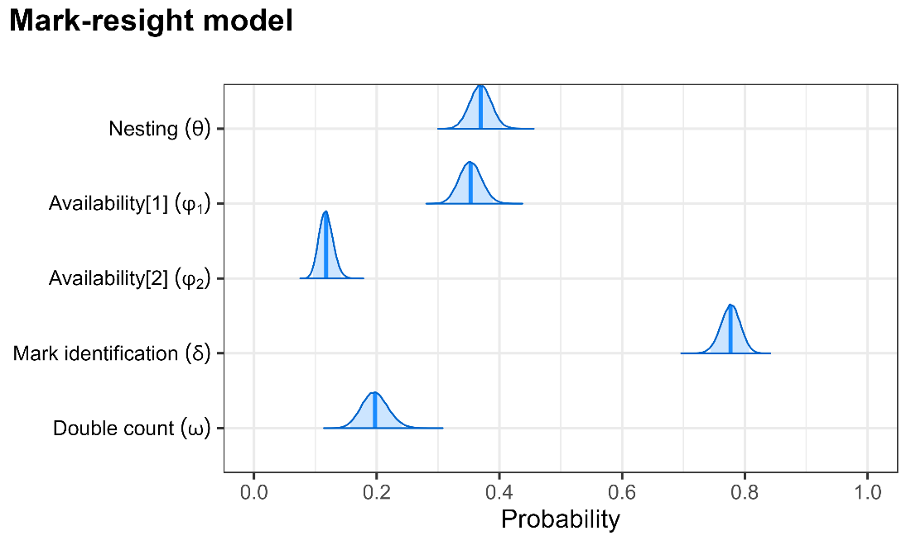

**Figure 4.** Posterior distribution of the probabilities estimated from the mark-resight data in drone orthomosaics of Giant South American River Turtles (*Podocnemis expansa*) during a mass nesting event in the Guaporé/Iténez River (Amazonia). Availability[1] refers to individuals that were present in the sandbank during the night that were still available in the sunrise drone flight. Availability[2] is the probability of an individuals that used the sandbank in a previous day to be available during the flight in following days.

For the overall counts, the estimated number of new individuals entering the population per day varied between 19 (95% CI = 0-70) and 9,691 (95% CI = 8,429-11,119) (Figure 5b). We observed a general increase in the daily population size throughout the days from around 3,000 to around 14,000 (Figure 5c). The total number of female turtles that used the sandbank during the 12 days was estimated to be 41,377 (95% CI = 37,246-46,026). For comparison, we estimate total abundance with a simpler model for the orthomosaic counts. For this, we first estimated a single detection probability using the proportion of marked individuals at each day that appeared in the orthomosaic and the proportion of double counts for all detected turtles (not differentiating walking from nesting individuals). Then, we adjusted the daily counts for these two detection errors and summed them up to get an estimate of the total abundance. Note that this approach does not take into account the temporal dynamics of the individuals, the individual states (nesting or walking), and the unidentified marks. As expected, this resulted in a much higher estimate of total abundance of 78,879 individuals (71,708 – 86,993).

In addition to the comparison between different models for the orthomosaic counts, we also compare our results to visual ground counts. The visual ground counts were conducted simultaneously to the drone flights (6 am) by three independent observers who were located at the highest point of view of the sandbank. The mean count per day varied from 656 to 2,257 summing to 15,955 individuals throughout the 12 days of survey. In comparison to the orthomosaic counts, the ground counts were generally lower than the total drone counts, except on the day with the fewest number of turtles on the sandbank (Fig S1a). Critically, the difference between the two methods increased with the estimated turtle abundance (Fig S1b), suggesting that a greater number of individuals on the sandbank often leads to greater obstruction from a ground-level view, impeding a more accurate ground-level count.

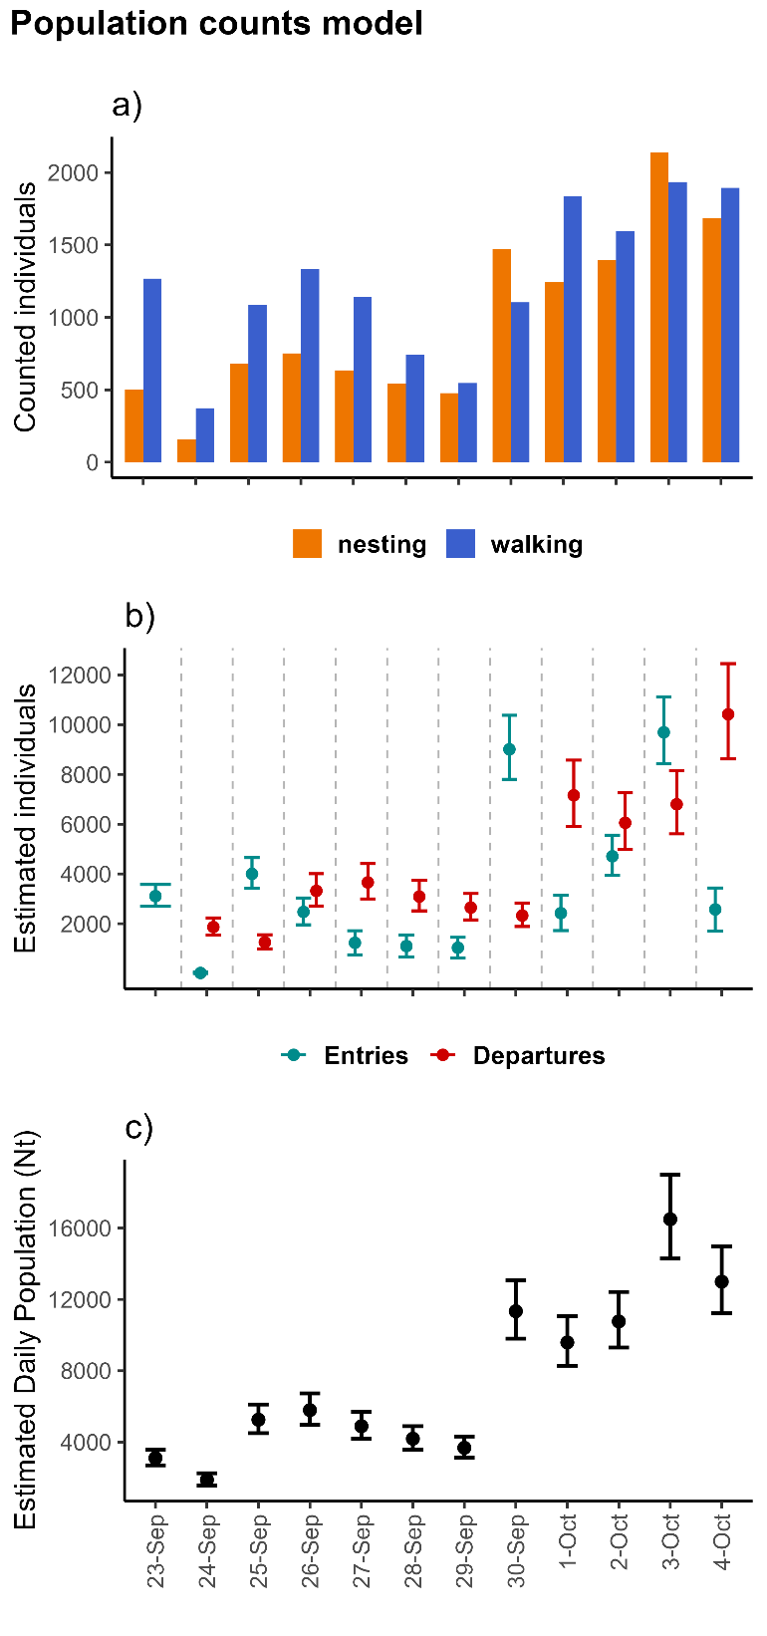

**Figure 5.** Population counts and resulting abundance estimates from orthomosaics of drone surveys of Giant South American River Turtles (*Podocnemis expansa*). a) Counts of nesting and walking individuals per day; b) estimated number of entrant and leaving individuals per day; and c) estimated daily population size.

**4. Discussion**

We developed a model to estimate abundance of spatially aggregated populations from drone-based counts in orthomosaics that accounts for multiple sources of false-negative and false-positive errors as well as the temporal dynamics of individuals entering and leaving the target area. To our knowledge, this is the first study to account simultaneously for these multiple sources of bias in orthomosaic counts of drone-based surveys. Our approach relies on an individual-level dataset (mark-resight data) to estimate availability and double counts under an open-population multi-state capture-recapture model. Importantly, the open-population approach with a superpopulation formulation permits accommodating the temporal dynamics of the individuals and thus the estimation of the total abundance throughout the entire study period. Using an example of river turtles during a mass nesting event, we showed how these errors can be significant and should not be ignored when counting individuals in orthomosaics. For instance, we found that only 35% of the individuals that use the sandbank during the night are present at the moment of the drone flight. Critically, we also found that on average 20% of the turtles detected walking in the orthomosaic correspond to double counts, and that a single individual can appear up to seven times in the mosaic. Our approach also accounted for the fact that some marked individuals detected in the orthomosaics had their marks unidentifiable (approximately 20% for the river turtles), which can cause biased parameter estimates. By comparing our results to those from a much simpler modeling approach, we highlight the importance of considering all these sources of variation in the counts, demonstrating that not properly accommodating them can lead to substantial bias in abundance estimates.

During the model development, we identified some general recommendations for designing orthomosaic drone surveys to count spatially aggregated wildlife populations. First, if the goal is to estimate the total number of individuals that use the aggregation site throughout the season, it is important that the sampling time window encompasses the entire period in which the site is used by the target wildlife species. To be feasible, this may require conducting surveys on alternate days. However, note that if the substitution of the population is expected to be high for the specified time interval (i.e., too many entries and departures), increasing the time interval between surveys can be problematic. Furthermore, marking a subset of individuals before each drone flight (as we did) can provide better information about the temporal variability of the parameters compared to marking only once before starting the surveys. Nevertheless, because individuals marked in the initial occasions have longer encounter histories and thus may contribute with more information for the parameter estimation, one could prioritize marking more individuals in these first visits. Future research using simulation experiments to evaluate sampling design strategies, including total survey duration, time interval between occasions, and when to mark individuals can be important for survey optimization in monitoring programs.

The formulation of our proposed model resembles previous approaches that combined counts and mark-resight data (with banding/ringing) to model abundance with temporal dynamics in bird migratory stopover sites (Lyons et al., 2016; Matechou et al., 2013; Tucker et al., 2023). However, these former approaches did not include multiple states, the possibility of double counting individuals, and the presence of unidentifiable marks. Importantly, Matechou et al. (2013) explored the influence of double counting and unidentifiable marks using simulation experiments, and concluded that not taking into account these sources of error can result in abundance overestimation. Another source of error that can be accommodated in our modeling framework is the possibility of misdetecting an individual nesting as walking, to account for individuals that appear in the orthomosaic walking before or after nesting. We briefly explored with simulations a version of the model that accommodates the misdetection of the state of the individual by including a specific misdetection probability in the detection matrix. The results of this model were promising, especially for scenarios in which several individuals are recaptured on multiple occasions after the marking. However, we did not consider this model formulation for the turtle data because the probability of misdetection was estimated to be very close to zero, suggesting that this type of misdetection is insignificant for this dataset.

The developed approach can be applied to other contexts in which spatially aggregated populations are surveyed using drone-derived orthomosaics. For instance, drones have been used to survey freshwater turtles in basking areas (Bogolin et al., 2021) and sea turtles in nesting sites (Rees et al., 2018; Thorson et al., 2012). Furthermore, orthomosaics are a common approach used in surveys of haul-out sites and nesting or breeding colonies of seals and birds (e.g., Goebel et al., 2015; Kellenberger et al., 2021; Korczak-Abshire et al., 2019; Procksch et al., 2023; Weinstein et al., 2022). Obviously, these different contexts may require some adaptations, such as other approaches to mark individuals. For example, seals were marked for drone surveys by clipping their fur (Sorrell et al., 2019), elks were attached with high-visibility collars to be resighted in aerial surveys (Bear et al., 1989), and different ungulate species have been marked with paintballs for aerial resighting (Pauley & Crenshaw, 2006; Skalski et al., 2005). Another important adaptation refers to which individual states to represent. When no differences are expected in the temporal dynamics among individuals of different classes, our modelling framework could be simplified to represent only two states: present and gone. However, some aggregated populations can present different temporal behaviors between adult males and females (and possibly juveniles) (e.g., Dujon et al., 2021; Infantes et al., 2022), potentially requiring the use of sex and/or age as multiple states. Multiple individual states might also need to be accounted for when studying bird nesting colonies, in which the nest stage (e.g., nest building, eggs incubation, nestling period) might influence the temporal dynamic of the adults (Gallego & Sarasola, 2021; Lachman et al., 2020; Sardà‐Palomera et al., 2017). Finally, it is important to think carefully if an open population or closed population assumption should be considered. For example, when surveying populations in which the same individuals use the area of aggregation throughout the sampling period (i.e., entries and departures are insignificant), the model can be simplified to a closed-population capture-recapture model, estimating only availability, double counts, and mark identification. For example, adult seals may use a haul-out site for resting between feeding periods throughout several weeks (Cordes & Thompson, 2015), with the same individuals using the area during this period.

Other types of data at the individual level (different from mark-resight data) may also be used in the proposed modelling framework. For example, GPS tracking data from telemetry devices have been used to estimate detection errors in aerial surveys, particularly to address availability and perception of individuals (Barker, 2008). In the context of our approach, if some individuals are telemetry tracked, it would be possible to estimate their availability during the drone flight based on their locations. Furthermore, by using these movement tracks during flights, it may be possible to model movement patterns and identify (or estimate) double counts. In conclusion, the developed approach provides a flexible framework that can be tailored for a wide variety of species and contexts according to the nature of the aggregated population (i.e., closed or open), the various possible individual states, and the different types of individual-level data to be collected.

***4.1. Conservation and Management implications***

The Giant South American River Turtle has experienced historical declines. Originally, its abundance was significantly greater, and mass nesting occurred in many tributaries of the Amazon and Orinoco Rivers, but more recently it has either disappeared from many of these rivers or is now present in much lower densities. Yet, there are still some large populations of the species across its range, and some of them seem to be recovering (Forero-Medina et al., 2021). The seasonal behavior of this species, aggregating and nesting in sandbanks during the dry season, provides an invaluable opportunity to monitor its populations. One traditional method for estimating the number of nesting females is counting the nests, particularly for small aggregations. However, estimating abundance in areas with substantial mass nesting using such method becomes challenging or even impossible because individual nests cannot be distinguished from each other. Another common method for estimating abundance of river turtles is counting the hatchlings when they emerge. Yet, counting hatchlings presents important challenges, potentially providing biased abundance estimates (Norris, 2025), besides being a more invasive and laborious approach. Importantly, we have shown that visual ground counts can also be an ineffective approach for assessing abundance during mass nesting events due to the obstruction of the ground-level view that large numbers of individuals cause.

Therefore, the presented approach has important advantages for monitoring aggregated turtle populations. First, the aerial images provide a great point of view to count the turtles without obstructions. Second, a standardized method that could be applied and compared across different sites and different years, with the estimation of associated uncertainty, delivers a more robust assessment of population size and trends. Furthermore, using a less invasive technique that reduces manipulation and disturbance of animals, such as drone-based surveys, is particularly important for imperiled species. We therefore foresee the establishment of a collaborative network of governmental and non-governmental institutions across the mass nesting areas of river turtles to monitor the species using a similar protocol to the one that we developed.

The estimated number of females in this study confirms the uttermost importance of this site for the conservation of the species. Our estimated total abundance for the aggregation site during 12 continuous days of mass nesting was 41,377 turtles. This estimate is higher than any other mass nesting recorded for the species (Forero-Medina et al., 2021). Since the nesting event continued for some days after the last drone flight, we can assume that a few thousand additional females still used this particular sandbank. Although this abundance estimate may represent a large number of river turtles, it is probably only a fraction of what the historical populations were in the Amazon region, based on historical records of exported eggs (Forero-Medina et al., 2021). The implementation of a monitoring protocol should consider extending the surveys throughout the entire nesting period. Furthermore, because there are other sandbanks in the region that the turtles also use to nest, it would be important to include them to have a comprehensive estimate of the nesting population in the region.

Seasonal aggregations of wildlife populations (e.g., haul-out sites, migratory stopover sites, nesting or breeding colonies) provide a great opportunity for efficiently estimating and monitoring abundance. Drone-based counts have been used to survey spatially aggregated populations (Christie et al., 2016; Lyons et al., 2019), but there has been little awareness of the multiple detection errors that may affect counts and consequently bias population estimates. The use of orthomosaics generated from drone flights is becoming an increasingly common approach to survey aggregated wildlife populations and, for this reason, we believe the developed methodology has great potential to be applied (and adapted) to many different contexts in which threatened species are surveyed using drone-based orthomosaics. Ultimately, we expect that this approach will contribute to the efficient and timely monitoring of abundance in wildlife conservation and management programs.

Please ensure that these sections are included in the following order:

1. Acknowledgements

2. Conflict of Interest Statement ; Please add a Conflict of Interest statement (this should appear between your Acknowledgements and Author's Contributions statement). If none of the authors have a conflict of interest, please state this. You can find out more about our Conflict of Interest policy here: https://besjournals.onlinelibrary.wiley.com/hub/editorial-policies#interest.

3. Authors' Contributions (please put your Statement of Inclusion as a sub-heading at the end if you'd like to include this) ; Please check the authors’ contributions statement in line with our authorship criteria, checking the description of each person’s involvement meets these criteria: https://besjournals.onlinelibrary.wiley.com/hub/journal/13652664/about/author-guidelines#ManuscriptSpecifications. Please note, every author must be mentioned in this section and every author must be mentioned by their full name e.g. Lydia Groves, rather than their initials.

4. Data Availability Statement ; In order to meet the journal’s data accessibility policy, please archive all data used for this paper in a publicly accessible repository. You can find more information about our policy in the decision letter. For theoretical papers, the model code should be archived. We do not allow data to be archived in Supporting Information.

If you decide to archive any of your data in Dryad, which is integrated with the British Ecological Society journals and where we will cover the cost of the deposit (up to 20GB), please email admin@journalofappliedecology.org first so we can set up a placeholder with you.

Please include the DOI for your data/code here. The statement should follow this structure:

'Data available via the Dryad Digital Repository https://doi.org/10.5061/dryad.2d0g778 (Girard,Shea, & Fisher, 2018)‘.

Please also add a reference to the data set to the reference list e.g. ‘Girard F, Shea K, Fisher CR (2018) Data from: Projecting the recovery of a long-lived deep-sea octocoral species after the Deepwater Horizon oil spill using structured population models. Dryad Digital Repository. https://doi.org/10.5061/dryad.2d0g778

*PLEASE NOTE: We are unable to proceed with the production process until your data is published and the DOI is live. Please wait until this stage is complete before you return your final files*

**References**

Alho, C. J. R., & Pádua, L. F. M. (1982). Reproductive parameters and nesting behavior of the Amazon turtle *Podocnemis expansa* (Testudinata: Pelomedusidae) in Brazil. *Canadian Journal of Zoology*, *60*(1), 97–103. https://doi.org/10.1139/z82-012

Barker, R. (2008). Theory and application of mark - recapture and related techniques to aerial surveys of wildlife. *Wildlife Research*, *35*(4), 268. https://doi.org/10.1071/WR07086

Bear, G. D., White, G. C., Carpenter, L. H., Gill, R. B., & Essex, D. J. (1989). Evaluation of Aerial Mark-Resighting Estimates of Elk Populations. *The Journal of Wildlife Management*, *53*(4), 908. https://doi.org/10.2307/3809587

Bogolin, A. P., Davis, D. R., Kline, R. J., & Rahman, A. F. (2021). A drone-based survey for large, basking freshwater turtle species. *PLOS ONE*, *16*(10), e0257720. https://doi.org/10.1371/journal.pone.0257720

Brack, I. V., Kindel, A., & Oliveira, L. F. B. (2018). Detection errors in wildlife abundance estimates from Unmanned Aerial Systems (UAS) surveys: Synthesis, solutions, and challenges. *Methods in Ecology and Evolution*, *9*(8), 1864–1873. https://doi.org/10.1111/2041-210X.13026

Brooks, S. P., & Gelman, A. (1998). General Methods for Monitoring Convergence of Iterative Simulations General Methods for Monitoring Convergence of Iterative Simulations. *Journal of Computational and Graphical Statistics*, *7*(4), 434–455. https://doi.org/10.1080/10618600.1998.10474787

Brown, C. R. (2016). The ecology and evolution of colony-size variation. *Behavioral Ecology and Sociobiology*, *70*(10), 1613–1632. https://doi.org/10.1007/s00265-016-2196-x

Butchart, S. H. M., Walpole, M., Collen, B., van Strien, A., Scharlemann, J. P. W., Almond, R. E. A., Baillie, J. E. M., Bomhard, B., Brown, C., Bruno, J., Carpenter, K. E., Carr, G. M., Chanson, J., Chenery, A. M., Csirke, J., Davidson, N. C., Dentener, F., Foster, M., Galli, A., … Watson, R. (2010). Global Biodiversity: Indicators of Recent Declines. *Science*, *328*(5982), 1164–1168. https://doi.org/10.1126/science.1187512

Calvert, A. M., Bonner, S. J., Jonsen, I. D., Flemming, J. M., Walde, S. J., & Taylor, P. D. (2009). A hierarchical Bayesian approach to multi‐state mark–recapture: simulations and applications. *Journal of Applied Ecology*, *46*(3), 610–620. https://doi.org/10.1111/j.1365-2664.2009.01636.x

Christie, K. S., Gilbert, S. L., Brown, C. L., Hatfield, M., & Hanson, L. (2016). Unmanned aircraft systems in wildlife research: current and future applications of a transformative technology. *Frontiers in Ecology and the Environment*, *14*(5), 241–251. https://doi.org/10.1002/fee.1281

Cohen, E. B., Horton, K. G., Marra, P. P., Clipp, H. L., Farnsworth, A., Smolinsky, J. A., Sheldon, D., & Buler, J. J. (2021). A place to land: spatiotemporal drivers of stopover habitat use by migrating birds. *Ecology Letters*, *24*(1), 38–49. https://doi.org/10.1111/ele.13618

Cordes, L. S., & Thompson, P. M. (2015). Mark‐resight estimates of seasonal variation in harbor seal abundance and site fidelity. *Population Ecology*, *57*(3), 467–472. https://doi.org/10.1007/s10144-015-0496-z

de Valpine, P., Paciorek, C., Turek, D., Michaud, N., Anderson-Bergman, C., Obermeyer, F., Wehrhahn Cortes, C., Rodríguez, A., Temple Lang, D., Zhang, W., Paganin, S., Hug, J., & van Dam-Bates, P. (2024). *NIMBLE: MCMC, Particle Filtering, and Programmable Hierarchical Modeling*. https://doi.org/10.5281/zenodo.1211190

de Valpine, P., Turek, D., Paciorek, C. J., Anderson-Bergman, C., Temple Lang, D., & Bodik, R. (2017). Programming with models: writing statistical algorithms for general model structures with NIMBLE. *Journal of Computational and Graphical Statistics*, *26*, 403–417. https://doi.org/10.1080/10618600.2016.1172487

Dujon, A. M., Ierodiaconou, D., Geeson, J. J., Arnould, J. P. Y., Allan, B. M., Katselidis, K. A., & Schofield, G. (2021). Machine learning to detect marine animals in UAV imagery: effect of morphology, spacing, behaviour and habitat. *Remote Sensing in Ecology and Conservation*, *7*(3), 341–354. https://doi.org/10.1002/rse2.205

Fagundes, C. K., & Ferrara, C. R. (2022). The Use of Unmanned aerial Vehicles (UaVs) To sTUdy a freshwaTer TUrTle PoPUlaTion in The Brazilian amazon. In *Herpetological Conservation and Biology* (Vol. 17, Issue 1).

Ferrara, C. R., Schneider, L., & Vogt, R. C. (2010). Natural history notes: Podocnemis expansa Pre-Nesting Basking Behavior. *Herpetological Review*, *41*(1), 72–72.

Ferrara, C. R., Vogt, R. C., Sousa-Lima, R. S., Tardio, B. M. R., & Bernardes, V. C. D. (2014). Sound Communication and Social Behavior in an Amazonian River Turtle ( *Podocnemis expansa* ). *Herpetologica*, *70*(2), 149–156. https://doi.org/10.1655/HERPETOLOGICA-D-13-00050R2

Forero-Medina, G., Ferrara, C. R., Vogt, R. C., Fagundes, C. K., Balestra, R. A. M., Andrade, P. C. M., Lacava, R., Bernhard, R., Lipman, A. J., Lenz, A. J., Ferrer, A., Calle, A., Aponte, A. F., Calle-Rendón, B. R., Santos Camilo, C., Perrone, E., Miraña, E., Cunha, F. A. G., Loja, E., … Horne, B. D. (2021). On the future of the giant South American river turtle *Podocnemis expansa*. *Oryx*, *55*(1), 73–80. https://doi.org/10.1017/S0030605318001370

Gallego, D., & Sarasola, J. H. (2021). Using drones to reduce human disturbance while monitoring breeding status of an endangered raptor. *Remote Sensing in Ecology and Conservation*, *7*(3), 550–561. https://doi.org/10.1002/rse2.206

Gimenez, O., Rossi, V., Choquet, R., Dehais, C., Doris, B., Varella, H., Vila, J.-P., & Pradel, R. (2007). State-space modelling of data on marked individuals. *Ecological Modelling*, *206*(3–4), 431–438. https://doi.org/10.1016/j.ecolmodel.2007.03.040

Goebel, M. E., Perryman, W. L., Hinke, J. T., Krause, D. J., Hann, N. A., Gardner, S., & LeRoi, D. J. (2015). A small unmanned aerial system for estimating abundance and size of Antarctic predators. *Polar Biology*, *38*(5), 619–630. https://doi.org/10.1007/s00300-014-1625-4

Hodgson, J. C., Baylis, S. M., Mott, R., Herrod, A., & Clarke, R. H. (2016). Precision wildlife monitoring using unmanned aerial vehicles. *Scientific Reports*, *6*(March), 22574. https://doi.org/10.1038/srep22574

Hodgson, J. C., Mott, R., Baylis, S. M., Pham, T. T., Wotherspoon, S., Kilpatrick, A. D., Raja Segaran, R., Reid, I., Terauds, A., & Koh, L. P. (2018). Drones count wildlife more accurately and precisely than humans. *Methods in Ecology and Evolution*, *9*(5), 1160–1167. https://doi.org/10.1111/2041-210X.12974

Hoekendijk, J. P. A., Grundlehner, A., Brasseur, S., Kellenberger, B., Tuia, D., & Aarts, G. (2023). Stay close, but not too close: aerial image analysis reveals patterns of social distancing in seal colonies. *Royal Society Open Science*, *10*(8). https://doi.org/10.1098/rsos.230269

Infantes, E., Carroll, D., Silva, W. T. A. F., Härkönen, T., Edwards, S. V., & Harding, K. C. (2022). An automated work-flow for pinniped surveys: A new tool for monitoring population dynamics. *Frontiers in Ecology and Evolution*, *10*. https://doi.org/10.3389/fevo.2022.905309

Jovani, R., Lascelles, B., Garamszegi, L. Z., Mavor, R., Thaxter, C. B., & Oro, D. (2016). Colony size and foraging range in seabirds. *Oikos*, *125*(7), 968–974. https://doi.org/10.1111/oik.02781

Kellenberger, B., Veen, T., Folmer, E., & Tuia, D. (2021). 21 000 birds in 4.5 h: efficient large‐scale seabird detection with machine learning. *Remote Sensing in Ecology and Conservation*, *7*(3), 445–460. https://doi.org/10.1002/rse2.200

Kendall, W. L., Conn, P. B., & Hines, J. E. (2006). COMBINING MULTISTATE CAPTURE–RECAPTURE DATA WITH TAG RECOVERIES TO ESTIMATE DEMOGRAPHIC PARAMETERS. *Ecology*, *87*(1), 169–177. https://doi.org/10.1890/05-0637

Kery, M. M., & Schaub, M. (2012). Bayesian Population Analysis Using WinBUGS. In *Bayesian Population Analysis Using WinBUGS*. Academic Press. https://doi.org/10.1016/C2010-0-68368-4

Korczak-Abshire, M., Zmarz, A., Rodzewicz, M., Kycko, M., Karsznia, I., & Chwedorzewska, K. J. (2019). Study of fauna population changes on Penguin Island and Turret Point Oasis (King George Island, Antarctica) using an unmanned aerial vehicle. *Polar Biology*, *42*(1), 217–224. https://doi.org/10.1007/s00300-018-2379-1

Krause, D. J., Hinke, J. T., Goebel, M. E., & Perryman, W. L. (2021). Drones Minimize Antarctic Predator Responses Relative to Ground Survey Methods: An Appeal for Context in Policy Advice. *Frontiers in Marine Science*, *8*. https://doi.org/10.3389/fmars.2021.648772

Lachman, D., Conway, C., Vierling, K., & Matthews, T. (2020). Drones provide a better method to find nests and estimate nest survival for colonial waterbirds: a demonstration with Western Grebes. *Wetlands Ecology and Management*, *28*(5), 837–845. https://doi.org/10.1007/s11273-020-09743-y

Linchant, J., Lisein, J., Semeki, J., Lejeune, P., & Vermeulen, C. (2015). Are unmanned aircraft systems (UASs) the future of wildlife monitoring? A review of accomplishments and challenges. *Mammal Review*, *45*(4), 239–252. https://doi.org/10.1111/mam.12046

Lyons, J. E., Kendall, W. L., Royle, J. A., Converse, S. J., Andres, B. A., & Buchanan, J. B. (2016). Population Size and Stopover Duration Estimation Using Mark–Resight Data and Bayesian Analysis of a Superpopulation Model. *Biometrics*, *72*(1), 262–271. https://doi.org/10.1111/biom.12393

Lyons, M. B., Brandis, K. J., Murray, N. J., Wilshire, J. H., McCann, J. A., Kingsford, R. T., & Callaghan, C. T. (2019). Monitoring large and complex wildlife aggregations with drones. *Methods in Ecology and Evolution*, *10*(7), 1024–1035. https://doi.org/10.1111/2041-210X.13194

Matechou, E., Morgan, B. J. T., Pledger, S., Collazo, J. A., & Lyons, J. E. (2013). Integrated Analysis of Capture-Recapture-Resighting Data and Counts of Unmarked Birds at Stop-Over Sites. *Journal of Agricultural, Biological, and Environmental Statistics*, *18*(1), 120–135. https://doi.org/10.1007/s13253-013-0127-0

Moussy, C., Burfield, I. J., Stephenson, P. J., Newton, A. F. E., Butchart, S. H. M., Sutherland, W. J., Gregory, R. D., McRae, L., Bubb, P., Roesler, I., Ursino, C., Wu, Y., Retief, E. F., Udin, J. S., Urazaliyev, R., Sánchez-Clavijo, L. M., Lartey, E., & Donald, P. F. (2022). A quantitative global review of species population monitoring. *Conservation Biology*, *36*(1), 1–14. https://doi.org/10.1111/cobi.13721

Norris, D. (2025). Misleading monitoring: more hatchlings do not represent turtle population recovery. *BioRxiv*, 2025.02.14.638251. https://doi.org/10.1101/2025.02.14.638251

Pauley, G. R., & Crenshaw, J. G. (2006). Evaluation of Paintball, Mark-Resight Surveys for Estimating Mountain Goat Abundance. *Wildlife Society Bulletin*, *34*(5), 1350–1355. https://doi.org/10.2193/0091-7648(2006)34[1350:EOPMSF]2.0.CO;2

Pouilly, M., Pérez, T., Rejas, D., Guzman, F., Crespo, G., Duprey, J.-L., & Guimarães, J.-R. D. (2012). Mercury bioaccumulation patterns in fish from the Iténez river basin, Bolivian Amazon. *Ecotoxicology and Environmental Safety*, *83*, 8–15. https://doi.org/10.1016/j.ecoenv.2012.05.018

Procksch, N., Berchieri, N. B., Horota, R. K., Sales, V., Ott, P. H., Danilewicz, D., Guimaraes, T. T., Guimarães, M., Veronez, M. R., & Oliveira, L. R. de. (2023). Habitat use by South American fur seals (Arctocephalus australis) and sea lions (Otaria flavescens) in a marine protected area in southern Brazil. *Marine Policy*, *155*(June), 0–2. https://doi.org/10.1016/j.marpol.2023.105693

Procksch, N., Grandi, M. F., Ott, P. H., Groch, K., Flores, P. A. C., Zagonel, M., Crespo, E. A., Machado, R., Pavez, G., Guimarães, M., Veronez, M., & de Oliveira, L. R. (2020). The northernmost haulout site of South American sea lions and fur seals in the western South Atlantic. *Scientific Reports*, *10*(1), 1–15. https://doi.org/10.1038/s41598-020-76755-2

R Core Team. (2023). *R: A Language and Environment for Statistical Computing*. https://www.R-project.org/

Ratcliffe, N., Guihen, D., Robst, J., Crofts, S., Stanworth, A., & Enderlein, P. (2015). A protocol for the aerial survey of penguin colonies using UAVs. *Journal of Unmanned Vehicle Systems*, *3*(3), 95–101. https://doi.org/10.1139/juvs-2015-0006

Rees, A., Avens, L., Ballorain, K., Bevan, E., Broderick, A., Carthy, R., Christianen, M., Duclos, G., Heithaus, M., Johnston, D., Mangel, J., Paladino, F., Pendoley, K., Reina, R., Robinson, N., Ryan, R., Sykora-Bodie, S., Tilley, D., Varela, M., … Godley, B. (2018). The potential of unmanned aerial systems for sea turtle research and conservation: a review and future directions. *Endangered Species Research*, *35*, 81–100. https://doi.org/10.3354/esr00877

Rolland, C., Danchin, E., & de Fraipont, M. (1998). The Evolution of Coloniality in Birds in Relation to Food, Habitat, Predation, and Life‐History Traits: A Comparative Analysis. *The American Naturalist*, *151*(6), 514–529. https://doi.org/10.1086/286137

Sardà‐Palomera, F., Bota, G., Padilla, N., Brotons, L., & Sardà, F. (2017). Unmanned aircraft systems to unravel spatial and temporal factors affecting dynamics of colony formation and nesting success in birds. *Journal of Avian Biology*, *48*(9), 1273–1280. https://doi.org/10.1111/jav.01535

Scheelings, T. F. (2023). Reproduction in Sea Turtles, a Review. *Journal of Herpetological Medicine and Surgery*, *33*(2). https://doi.org/10.5818/jhms-d-22-00041

Schmaljohann, H., Eikenaar, C., & Sapir, N. (2022). Understanding the ecological and evolutionary function of stopover in migrating birds. *Biological Reviews*, *97*(4), 1231–1252. https://doi.org/10.1111/brv.12839

Skalski, J. R., Millspaugh, J. J., & Spencer, R. D. (2005). Population Estimation and Biases in Paintball, Mark-Resight Surveys of Elk. *Journal of Wildlife Management*, *69*(3), 1043–1052. https://doi.org/https://doi.org/10.2193/0022-541X(2005)069[1043:PEABIP]2.0.CO;2

Sorrell, K. J., Clarke, R. H., Holmberg, R., & McIntosh, R. R. (2019). Remotely piloted aircraft improve precision of capture–mark–resight population estimates of Australian fur seals. *Ecosphere*, *10*(8). https://doi.org/10.1002/ecs2.2812

Thorson, J. T., Punt, A. E., & Nel, R. (2012). Evaluating population recovery for sea turtles under nesting beach protection while accounting for nesting behaviours and changes in availability. *Journal of Applied Ecology*, *49*(3), 601–610. https://doi.org/10.1111/j.1365-2664.2012.02143.x

Tucker, A. M., McGowan, C. P., Nuse, B. L., Lyons, J. E., Moore, C. T., Smith, D. R., Sweka, J. A., Anstead, K. A., DeRose‐Wilson, A., & Clark, N. A. (2023). Estimating recruitment rate and population dynamics at a migratory stopover site using an integrated population model. *Ecosphere*, *14*(2). https://doi.org/10.1002/ecs2.4439

Weinstein, B. G., Garner, L., Saccomanno, V. R., Steinkraus, A., Ortega, A., Brush, K., Yenni, G., McKellar, A. E., Converse, R., Lippitt, C. D., Wegmann, A., Holmes, N. D., Edney, A. J., Hart, T., Jessopp, M. J., Clarke, R. H., Marchowski, D., Senyondo, H., Dotson, R., … Ernest, S. K. M. (2022). A general deep learning model for bird detection in high-resolution airborne imagery. *Ecological Applications*, *32*(8), 1–12. https://doi.org/10.1002/eap.2694

Westoby, M. J., Brasington, J., Glasser, N. F., Hambrey, M. J., & Reynolds, J. M. (2012). ‘Structure-from-Motion’ photogrammetry: A low-cost, effective tool for geoscience applications. *Geomorphology*, *179*, 300–314. https://doi.org/10.1016/j.geomorph.2012.08.021

White, G. C., Kendall, W. L., & Barker, R. J. (2010). Multistate Survival Models and Their Extensions in Program MARK. *Journal of Wildlife Management*, *70*(6), 1521–1529. https://doi.org/10.2193/0022-541X(2006)70[1521:MSMATE]2.0.CO;2

Wolf, P. R., Dewitt, B. A., & Wilkinson, B. E. (2014). *Elements of Photogrammetry with Applications in GIS* (4th edition). McGraw Hill Education. www.mhprofessional.com.